Bài 6
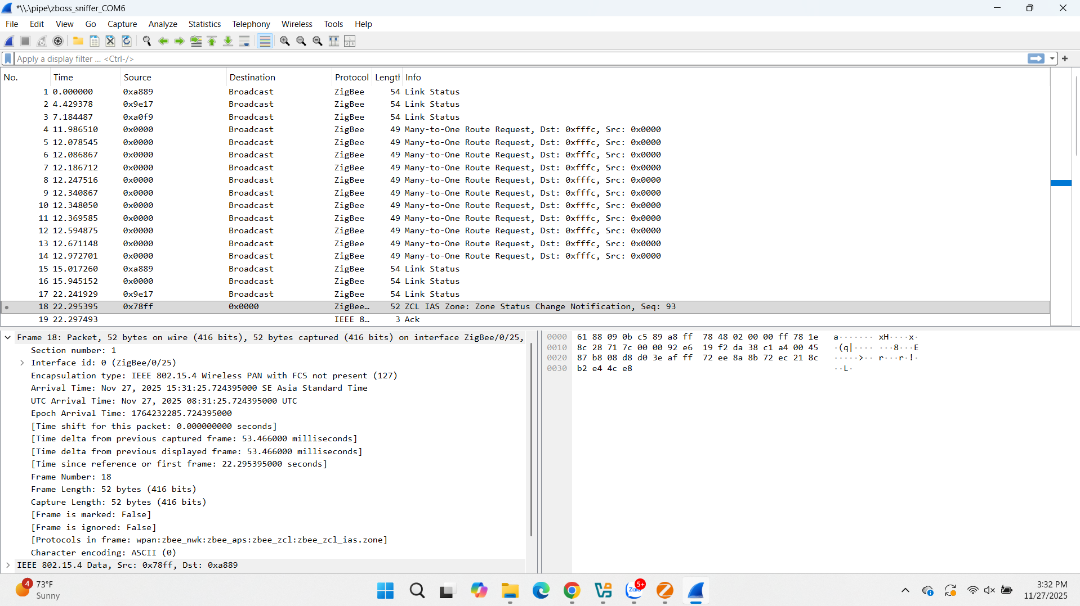

PAN ID = 0x0000
Source address 16bit: 0x878f
Destination Address 16bit: 0x8889
Sequence Number: 93 (0x5D)
Chanel:
Băng tần: 2.4Ghz

